Estrutura do projeto:

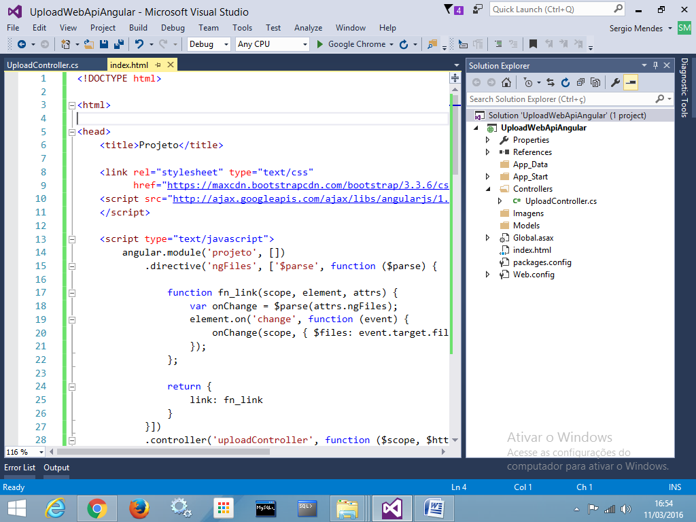

Página **index.html**

<!DOCTYPE html>

<html>

<head>

<title>Projeto</title>

<link rel="stylesheet" type="text/css"

href="https://maxcdn.bootstrapcdn.com/bootstrap/3.3.6/css/bootstrap.min.css" />

<script

src="http://ajax.googleapis.com/ajax/libs/angularjs/1.4.4/angular.min.js">

</script>

<script type="text/javascript">

angular.module('projeto', [])

.directive('ngFiles', ['$parse', function ($parse) {

function fn_link(scope, element, attrs) {

var onChange = $parse(attrs.ngFiles);

element.on('change', function (event) {

onChange(scope, { $files: event.target.files });

});

};

return {

link: fn_link

}

}])

.controller('uploadController', function ($scope, $http) {

var dados = new FormData();

$scope.getTheFiles = function ($files) {

angular.forEach($files, function (value, key) {

dados.append(key, value);

});

};

$scope.uploadFiles = function () {

var request = {

method: 'POST',

url: '/services/upload/gravar',

data: dados,

headers: {

'Content-Type': undefined

}

};

$http(request)

.success(function (d) {

$scope.mensagem = d;

})

.error(function (e) {

$scope.mensagem = e;

});

}

});

</script>

</head>

<body class="container" ng-app="projeto">

<h3>Exemplo - Upload de Arquivos em AngularJS com WebApi</h3>

<hr />

<div class="well col-md-3" ng-controller="uploadController">

<label>Selecione o Arquivo desejado:</label> <br />

<input type="file" id="file1" name="file" multiple

accept=".jpg" class="form-control"

ng-files="getTheFiles($files)" />

<br />

<input type="button" ng-click="uploadFiles()"

value="Enviar para o Servidor"

class="btn btn-primary btn-block" />

<br /><br />

**{{**mensagem**}}**

</div>

</body>

</html>

UploadController.vb

using System;

using System.Collections.Generic;

using System.Linq;

using System.Net;

using System.Net.Http;

using System.Net.Http.Headers;

using System.Threading.Tasks;

using System.Web;

using System.Web.Http;

namespace UploadWebApiAngular.Controllers

{

[RoutePrefix("services/upload")]

public class UploadController : ApiController

{

[HttpPost]

[Route("gravar")]

public async Task<HttpResponseMessage> Post()

{

if (!Request.Content.IsMimeMultipartContent())

{

throw new HttpResponseException(

HttpStatusCode.UnsupportedMediaType);

}

try

{

var pasta = HttpContext.Current.Server.MapPath("/Imagens/");

var provider = new CustomMultipartFormDataStreamProvider

(pasta, ".jpg");

await Request.Content.ReadAsMultipartAsync(provider);

return Request.CreateResponse(HttpStatusCode.OK,

"Upload realizado com sucesso.");

}

catch (Exception ex)

{

return Request.CreateResponse(

HttpStatusCode.Forbidden, ex.Message);

}

}

}

//classe para gerar o nome do arquivo...

class CustomMultipartFormDataStreamProvider

: MultipartFormDataStreamProvider

{

private string _extensao;

public CustomMultipartFormDataStreamProvider

(string path, string extensao)

: base(path)

{

_extensao = extensao;

}

public override string GetLocalFileName(HttpContentHeaders headers)

{

return Guid.NewGuid().ToString() + _extensao;

}

}

}

**Testando:**

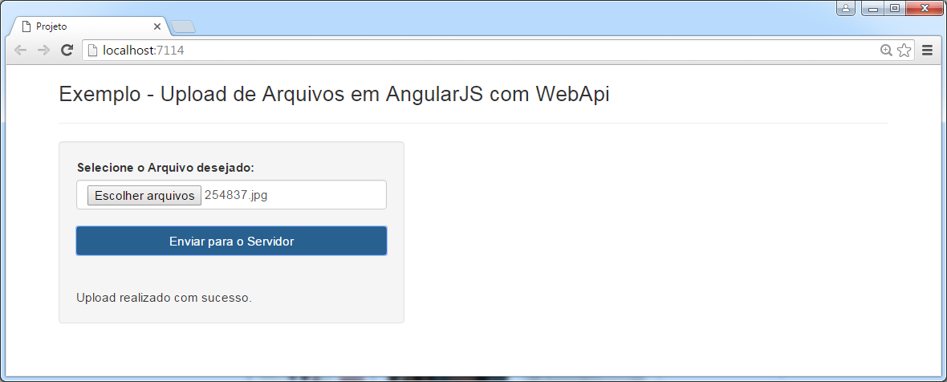

Na pasta /Imagens

